Source: WhatsApp Image 2026-01-19 at 9.36.54 AM (1).jpeg
#Colloidal solution (1nm-1000nm)
* Solute particle → dispersed phase
* Solvent particle → dispersed medium
② On basis of interaction force
* Attraction force → Lyophilic sol.
* Repulsion/no force → Lyophobic sol.
| Lyophilic | Lyophobic |
| :--------------------- | :-------------------- |
| 1. Stability→ not easily ppled | easily ppled |
| 2. Hydration→ more | less |
| 3. Nature→ organic starch | inorganic |
| 4. Surface tension→ lowest than medium | nearly same as medium |
③ On basis of size of colloids
(i) Multimolecular colloid
→ Chemical process (Oxidation, Reduction)
Hydrolysis,
eg. H₂S+SO₂ → S + H₂O displacement
s+s+s… →
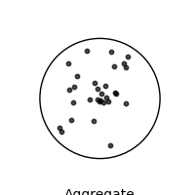
**Right Top Section:**
① On the basis of physical state
1. Solid-solid → solid sol → colored glass.
2. Solid-liq. → sol → paint.
3. Solid-gas → Aerosol → smoke, dust.
4. Liq.-Solid → Gel → Butter.
5. Liq-liq → Emulsion → milk
6. Liq-gas → Aerosol → fog, mist.
7. Gas-solid → solid sol → foam rubber
8. Gas-liq → foam → froth, whipped cream
(ii) Micromolecular colloid
If dispersed phase size already present
in colloidal size range
* Highly stable
* Starch, cellulose, protein, Nylon
(iii) Associated colloidal sol (Micelles)
True strong electrolyte
If conc. of electrolyte increase to
a specific conc., particle aggregate
↓ and form colloidal solution
Associated colloidal sol.
* specific conc. of electrolyte called
CMC (Critical micelles conc.)
* micelles formed above a particular
temp. called Kraft's temp
**Bottom Left Section:**
#Method of preparation of colloidal sol
(a) Chemical method:
Al₂O₃ + 3H₂S double disp → Al₂S₃ (sol) + 3H₂O
SO₂ + 2H₂S oxidation → 3S(sol) + 2H₂O
2AuCl₃ + 3HCHO + 3H₂O Rect → 2Au(sol) + 3HCOOH + 6HCl
FeCl₃ + 3H₂O Hydration Fe(OH)₃(sol) + 3HCl
(b) Peptization:
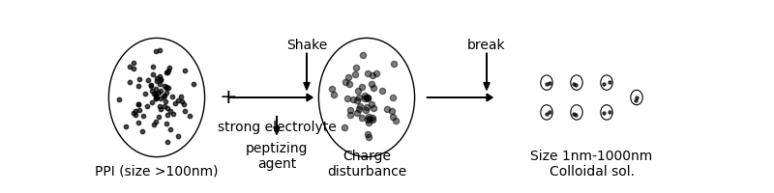
(c) Electric disintegration:
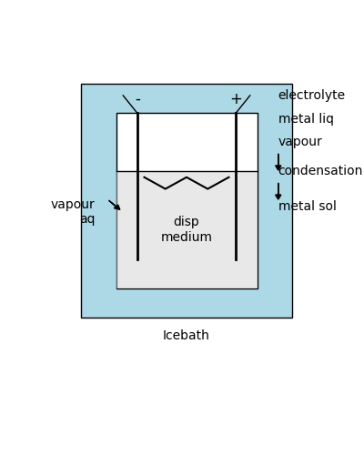
**Bottom Right Section:**
#Purification of colloidal solⁿ
1. Dialysis
2. Electrodialysis
3. Ultra filtration
(Filter paper + 4% nitrocellulose + Alkohol) → membrane
ether (ultrafilterpaper)
Hardening
by HCHO
Only true solⁿ ← Hard membs ← passes.

Source: WhatsApp Image 2026-01-19 at 9.36.54 AM.jpeg
SURFACE CHEMISTRY
#Adsorption: Accumulation of molecular species of the surface rather than bulk of solid or liquid.
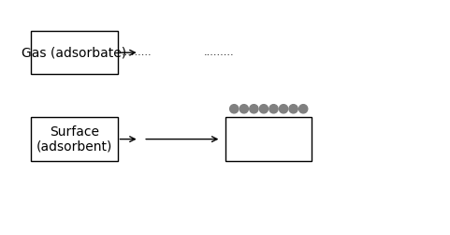
#Enthalpy (ΔH) = -ve (Exothermic)
#Entropy (ΔS) = -ve
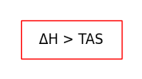
#Gibbs free energy (ΔG) = -ve
Desorption:
The process of removing
adsorbate from adsorbent.
Absorption:
when atom/molecule/ion enters
the bulk of solid or liquid.
eg. H₂O (vap) absorbed by CaCl₂
#Sorption:
adsorption & absorption Simultaneously
eg. Dyeing of fabric.
#Type of adsorption:
* Physical adsorption
* Van der Waals force
* Reversible force
* Low activation energy
* It is not specific
* Chemical adsorption
* Covalent force
* Irreversible
* High activation energy
* Highly specific.
#Easily liquifiable gases
form more physisorption
Physical adsorption ∝ α ∝ Tc α liquification
#Tc = 8a / 27Rb
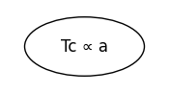
#Factors affecting adsorption
1. Nature of gas: Adsorption α dTc
2. Nature of adsorbent: adsorbent (activated)
3. Specific area of solid: adsorption α surface area
#Effect of temp on adsorption
Physisorption α 1/temp
Chemisorption α temp
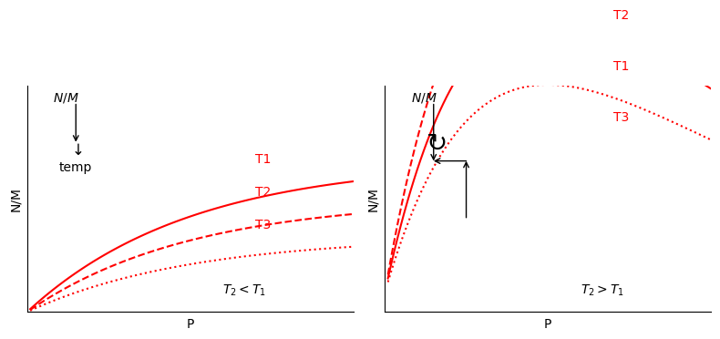
#Effect of pressure on gases
* Adsorption increase with increase in pressure.
#Freundlich adsorption isotherm
m gram adsorben -> x gm adsorbate accumulate
(x/m) = K P^(1/n) -> weight of adsorbate per gram adsorbent
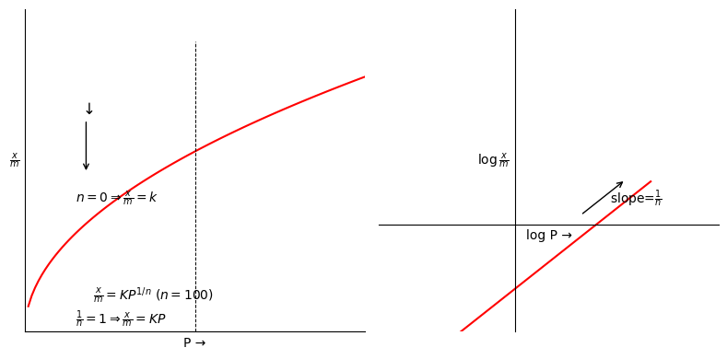
#Langmuir adsorption isotherm
x/m = aP / (1+bP) T -> Constant
a,b -> parameters.
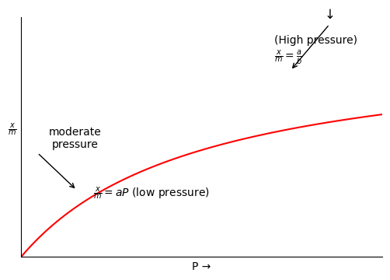

Source: WhatsApp Image 2026-01-19 at 9.36.55 AM.jpeg
# Properties of colloidal sol
1. **Colligative property:**
* value of colligative property
of colloidal sol. less than true sol.
* only depend on no. of solute particle.
True sol → aggregate → colloidal sol
size < 1nm size 1nm to 1000nm
3. **Color →** due to scattering of colloidal
color of colloidal sol depend on particle.
1. Size.
2. nature of particle.
5. **Charge on colloidal particle**
* colloidal particle always carry charge
* charge appear due to
(1) metal lose e⁻ → Mⁿ⁺
e⁻ captured by
colloidal particle.
(ii) colloidal particle preferentially
absorb ion on surface.
7. **Coagulation:**
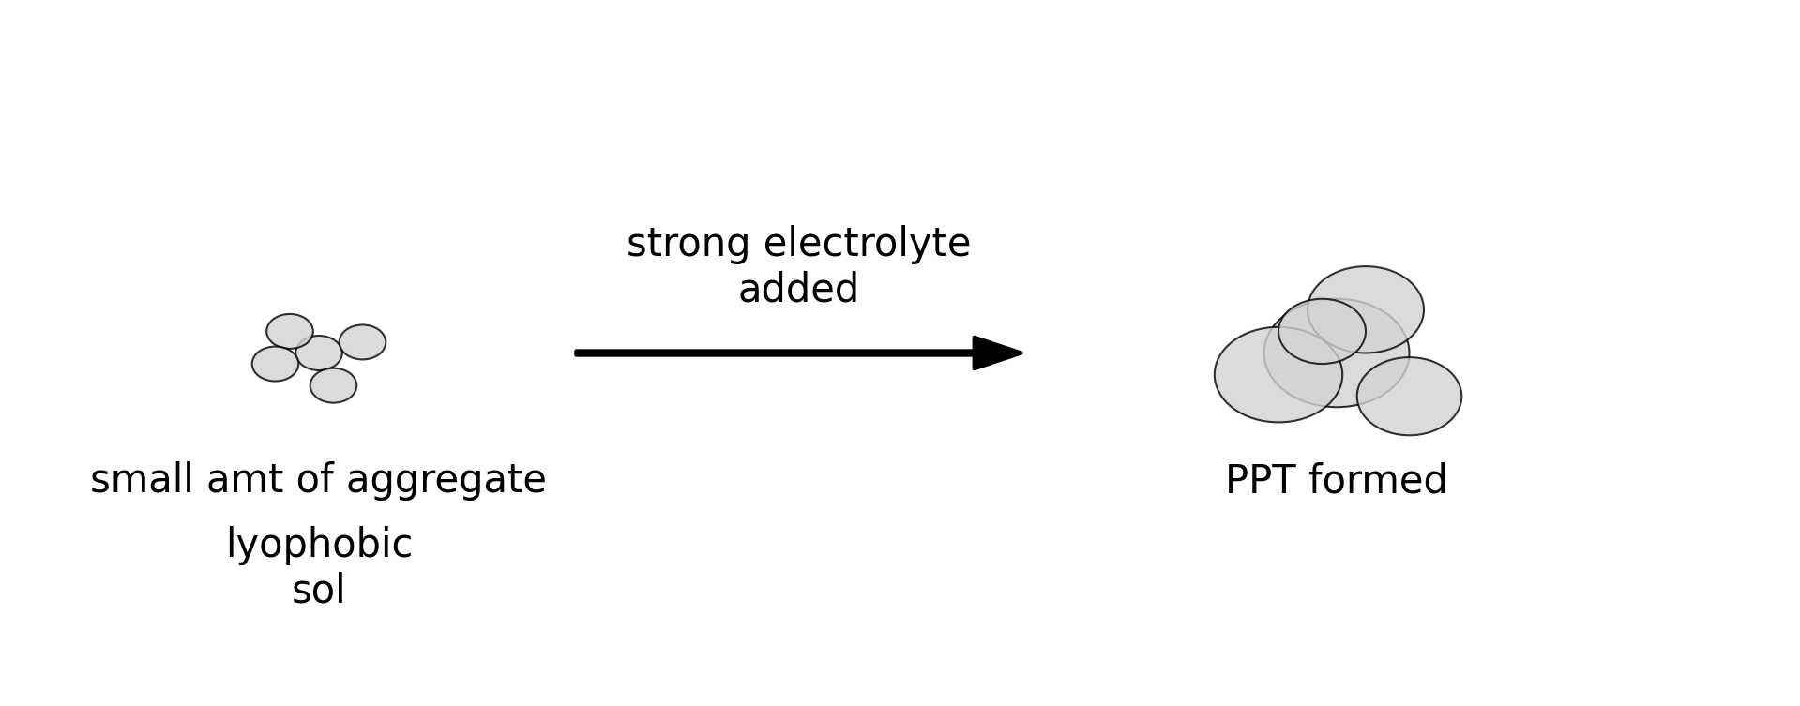
# Hardy Schulze Rule
* coagulating power ∝ charge on ion
* if lyophobic sol carrying +ve charge
coagulating power ∝ -ve charge of ion of
electrolyte.
* if lyophobic sol carry -ve charge
coagulating ∝ +ve charge of ion of
power electrolyte.
# Gold number
Gold no. = (Total no. of lyophilic sol added / Volume of lyophobic sol) × 100
power to stop coagulation ∝ 1/gold no.
# Promoter → increase activity of catalyst
# Inhibitor → decrease activity of catalyst.
(poison)
in contact process (formation of H₂SO₄)
Poison → As₂O₃
Catalyst → V₂O₅
---
2. **Tyndall Effect:**
Light → [True Sol] → Light
NO scattering
Condition of scattering
1. Size → large ⇒ Size of particle ≥ wave length
2. Refractive index → large difference
Tyndall effect doesn't depend on
nature of colloidal particle.
4. **Brownian movement**
colloidal particle are in continuous
zig zag motion.
* Viscosity ∝ size of colloidal particle
* speed ∝ 1/viscosity
6. **Electrophoresis**
movement of colloidal particle
under applied electric field.
* +ve charge towards anode (-ve)
* -ve charge towards cathode (+ve)
# Catalysis
catalyst
- only affect rate of rxn
- no participation in rxn
- enthalpy of rxn → no change
# Homogeneous catalyst # Heterogeneous catalyst
same phase diff phase
# Autocatalyst
Rxn me a molecule acts as catalyst.
CuFeS₂ Roasting → CuO + CuS + Fe₂O₃ ↓
CuO + CuS → Cu + SO₂
Autocatalyst.
# Induced catalyst
A → B non spontaneous
C → D spontaneous
But
A → B } together spontaneous.
C → D } induced catalyst
# Enzyme catalyst
- High molecular protein
- polymers of amino acid.

